Finite state automata

It is represented as a 5 tuple

(Q, sigma, delta, q0, F)

Q = finite set of states

Sigma = Finite set of alphabets

Delta = transition function

q0 = Starting state (belongs to Q)

F = Set of accepted states (subset of Q)

Delta, the transition function:

Delta: Q x Sigma -> Q

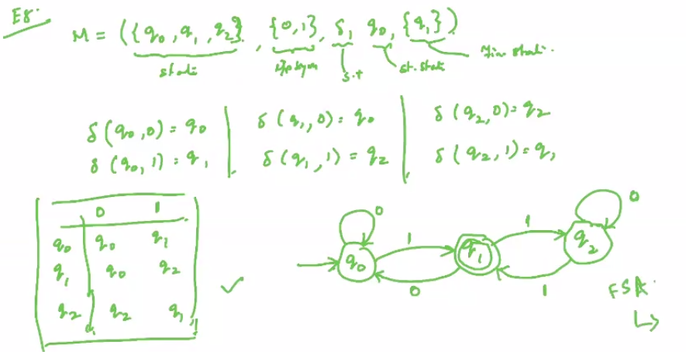

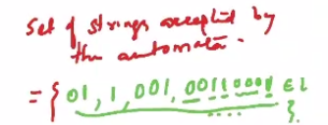

If an automaton is in final state after reading input string then the string belongs to the language accepted by the automaton.

A language accepted by a finite state automaton M = (Q, sigma, delta, q0, F) is the set of all strings in Sigma accepted by M. Formally:

